BAYLOR UNIVERSITY MODEL ORGANIZATION OF AMERICAN STATES TEAM SHINES AT SAN ANTONIO COMPETITION
This past weekend, November 3-5, Baylor Model Organization of American States (MOAS) team participated in the 15th Annual MOAS competition held at St. Mary’s University in San Antonio, Texas. In all, twenty delegations from the southwest and Mexico attended the model representing states across the Americas. Baylor University represented Honduras and Uruguay in the grueling three-day meet. In all twenty Baylor students participated; 18 students were delegates, while Michael Lyssy (Senior, International Studies major, Falls City, Texas) and Cindy Linkenhoger (Senior, Finance, Harlingen, Texas) served as Parliamentarian and Chair of the Inter-American Committee on Human Rights (IACHR). Amanda Honey (Senior, History, Celina, Texas) served as the Head Delegate of Uruguay and Ally Gutiérrez (Senior, International Studies, Cypress, Texas) served as the Head Delegate for Honduras. Participants at the model elected Rob Bradfield (Senior, Journalism, Waco, Texas) as president for the 2012 model. Baylor received a number of awards at this event including: Outstanding Chair (Cindy Linkenhoger), Distinguished Delegation (Honduras), Distinguished Ambassador and Distinguished Delegate for the General Committee (Amanda Honey), Outstanding Delegate in the Secretariat for Multidimensional Security (Rob Bradfield), Outstanding Delegate in the Executive Secretariat for Integral Development (Drew Vincent, Co-Head Delegate, Junior, International Studies, Mabelton, Georgia), Distinguished Delegate for the Secretariat for Political Affairs (Joan Stanton, Freshman, Political Science, Massapequa, New York), and Distinguished Delegate for IACHR (Rafael Deliz-Aguirre, Biology, Laredo, Texas). Baylor students also won awards for Outstanding Resolutions in the Executive Secretariat for Integral Development (Drew Vincent), and in IACHR (Cristina Mendez, sophomore, University Scholar, Brownsville, Texas). Other participants included Cody Brasher (Co-Head Delegate, Junior, International Studies, Moody, Alabama), Ewan Hamilton-Short (Freshman, Business Fellow, Waco, Texas), Diane Draper (Freshman, History, Waco, Texas), Brittany Harris (Senior, Accounting, Parker, Texas), Brittney Quesada (Senior, Political Science, Sugarland, Texas), Jimmy Smith (Senior, Political Science, Houston, Texas), Kristian Ramirez (Senior, History, San Antonio, Texas), Sheila González (Junior, Latin American Studies, Roma, Texas), Priscilla Escobedo (Sophomore, International Studies, Irving, Texas), Carlos Rodarte (Sophomore, International Studies, Houston, Texas, and Aaron Fields (Freshman, International Studies, Little Rock, Arkansas. The team was coached by Dr. Joan Supplee, the Ralph L. and Bessie Mae Lynn Professor of History.
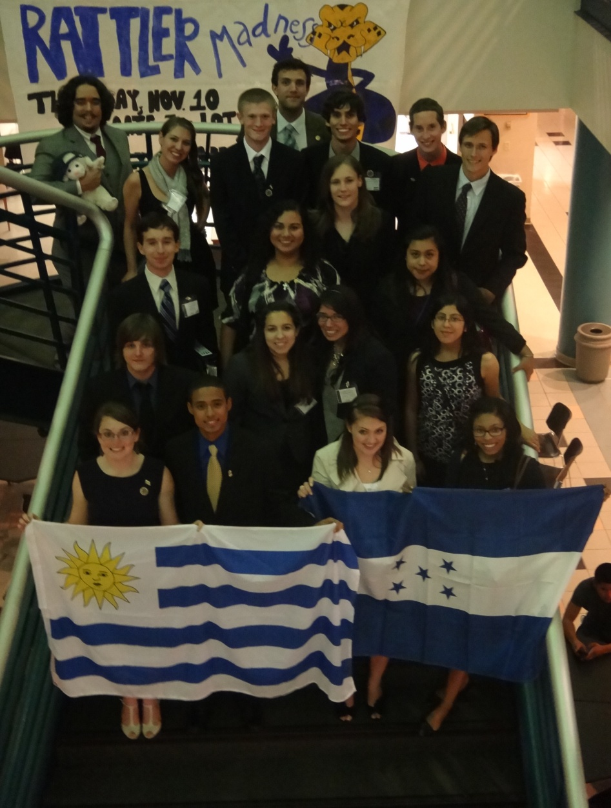
For more information, please contact:
Head Delegate: Amanada_Honey@baylor.edu
Head Delegate: Ally-Gutierrez@baylor.edu
Parliamentarian: Michael_Lyssy@baylor.edu
President-Elect: Rob_Bradfield@baylor.edu Advisor: Joan_Supplee@baylor.edu

