MOAS OFFICIAL ROSTER FALL 2016
MOAS LEADERSHIP
Joan Supplee Joan_Supplee@baylor.edu
President: Andrew Salinas Andrew_Salinas@baylor.edu
Secretary General: Jillian Anderson
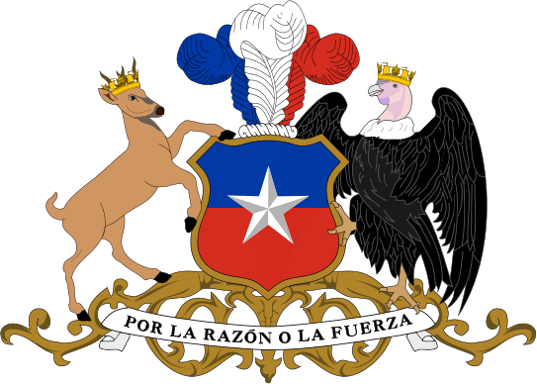
Rapporteurs: Emily Kleinburg, Mario Rangel Valenzuela
The Republic of Chile
General Committee
Mucia Flores, Head Delegate
Mucia_Flores@baylor.edu
SEDI
Ross McLaughlin
Ross_McLaughlin@baylor.edu
Maddy Abdallah
Maddy_Abdallah@baylor.edu
SSD
Clayton Jelincek
Clayton_Jelinek@baylor.edu
Brendan_Smith@baylor.edu
SMS
Rafael_Silva_Ramirez@baylor.edu
Audrey Chisum
Audrey_Chisum@baylor.edu
SAF
Torin Peterson
Torin_Peterson@baylor.edu
Makala Gordon
Makayla_Gorden@baylor.edu
MOAS OFFICIAL ROSTER 3.0 FALL 2016
MOAS LEADERSHIP
Joan Supplee Joan_Supplee@baylor.edu
President: Andrew Salinas Andrew_Salinas@baylor.edu
Secretary General: Jillian Anderson
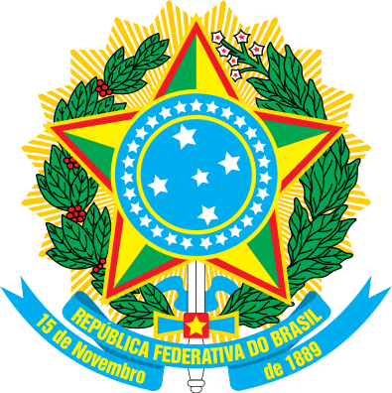
Rapporteurs: Emily Kleinburg, Mario Rangel Valenzuela
The Federative Republic of Brazil
General Committee
Gaby McCormack
Gaby_McCormack@baylor.edu
SEDI
Nate Chinnery
Nate_Chinnery@baylor.edu
Victoria Harrison
Victoria_Harrison@baylor.edu
SSD
Arianna Gomez
Arianna_Gomez@baylor.edu
Lawson Sadler
Lawson_Sadler@baylor.edu
SMS
Parker Wooden
Parker_Wooden@baylor.edu
Justin Plescha
Justin_Plescha@baylor.edu
SAF
Hannah Luce
Hannah_Luce@baylor.edu

